# Lesson 2 Modify Wi-Fi

## 1.**Modify Raspberry Pi Wi-Fi**

The computer is supposed to connect to the hotspot started with “HW” which is launched by Raspberry Pi. When there are multiple robots around, the wrong connection may occur. If you want to modify the default Wi-Fi name and password, please check the following steps.

1. Click  and select “Terminal Emulator” to open Ubuntu terminal.

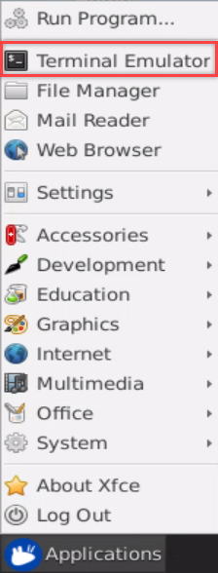

1. In the opened interface, enter command “**cd /boot/firmware/Hiwonder**” and press “Enter” to access to the directory of game programmings.

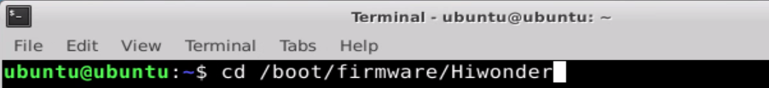

1. Enter command “sudo vim wifi.yaml” to open Wi-Fi configuration file via editor.

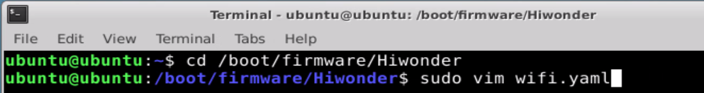

1. The interface is as the figure shown below:

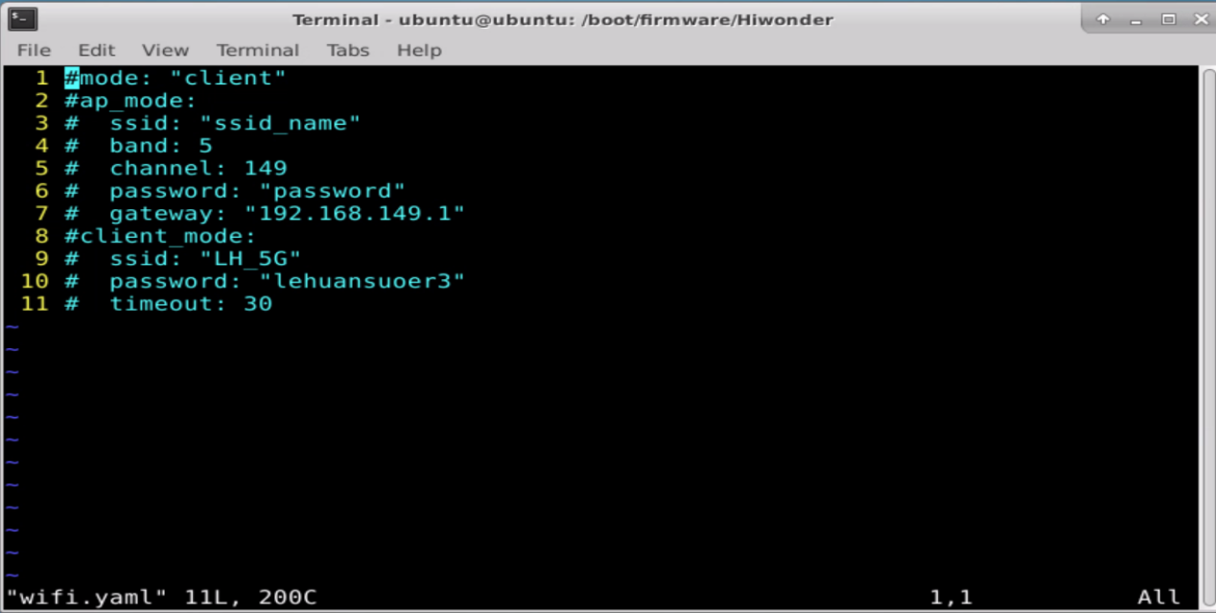

1. Press the "i" on the keyboard and then the "--Insert--" mark will be displayed on the interface. Please refer to the corresponding notes to modify.

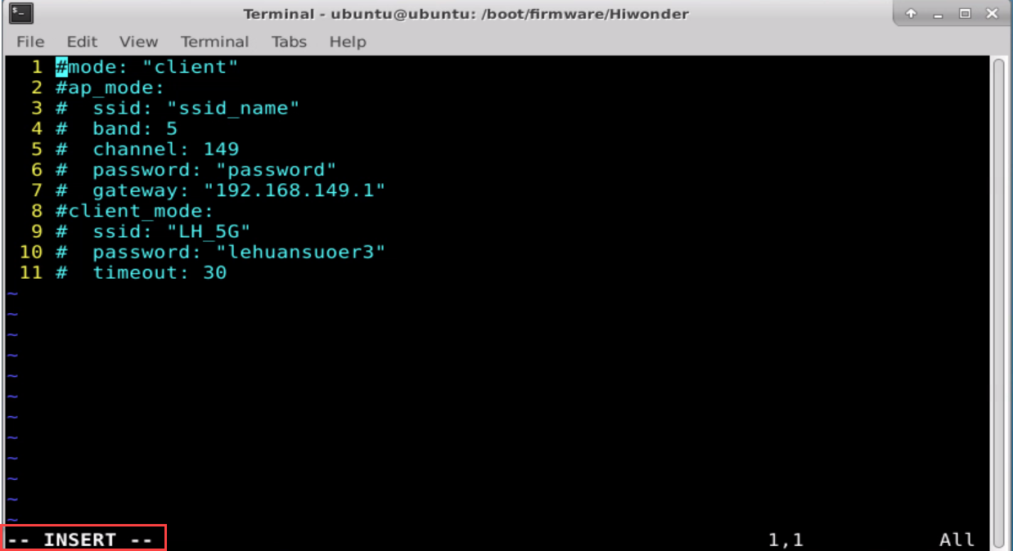

1. If want to modify the Raspberry Pi name as “Hiwonder” and password as “12345678”, you only need to revise the info as shown in the below figure. Do not forget to delete “#” to make it effective.

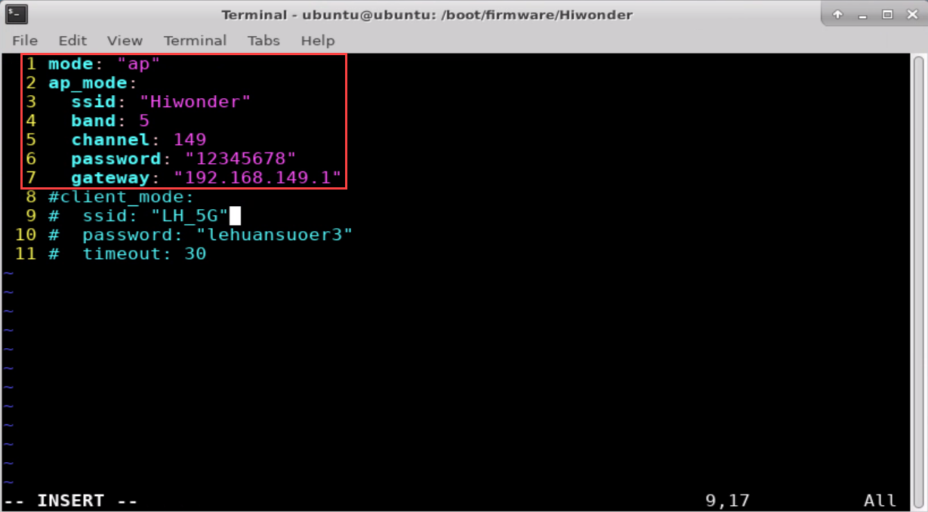

1. After the modification is complete, press “ESC” and enter “:wq”. Then save and exit the file.

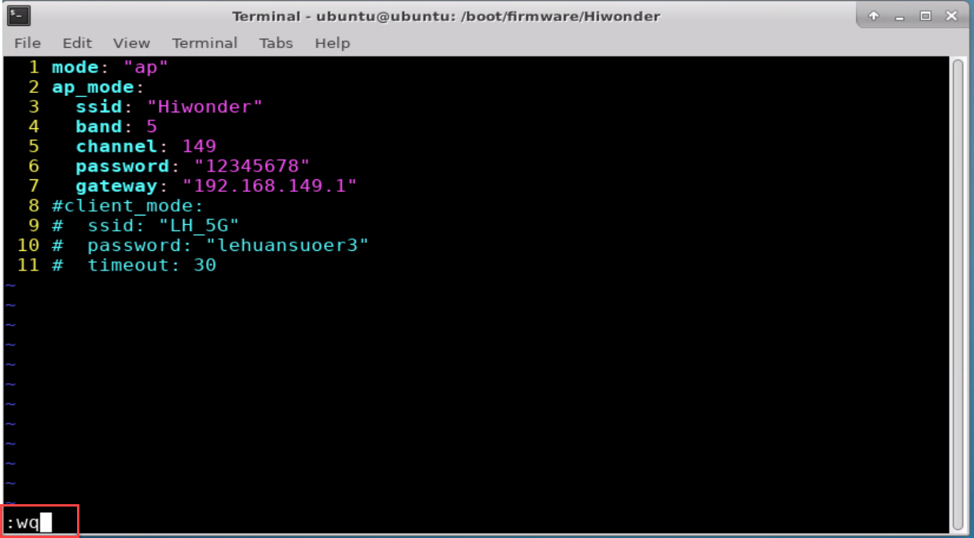

1. Enter command “**sudo systemctl restart hw-wifi.service**”. Then NoMachine will disconnect automatically and restart.

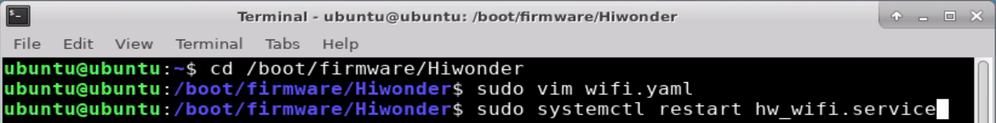

1. After restarting robot, the name of robot will is changed to “Hiwonder” and the password to “12345678”.